**Summary of Chapter 10**

* **Controlling**
  + The process of monitoring activities to ensure that they are being accomplished as planned and of correcting any significant deviations.
* **The Purpose of Control**
  + To ensure that activities are completed in ways that lead to accomplishment of organisational goals.

**Types of Control Systems used**

* **Market Control**

Emphasizes the use of external market mechanisms to establish the standards used in the control system.

External measures: price competition and relative market share

* **Bureaucratic Control**

Emphasizes organisationalauthority and relies on rules, regulations, procedures, and policies.

* **Clan Control**

Regulates behavior by shared values, norms, traditions, rituals, and beliefs of the firm’s culture.

**Why Is Control Important?**

* + **Planning**
    - Controls let managers know whether their goals and plans are on target and what future actions to take.
  + **Empowering employees**
    - Control systems provide managers with information and feedback on employee performance.
  + **Protecting the workplace**
    - Controls enhance physical security and help minimise workplace disruptions.
* **The Process of Control**
  + Measuring actual performance.
  + Comparing actual performance against a standard.
  + Taking action to correct deviations or inadequate standards.

**Common Sources of Information for Measuring Performance**

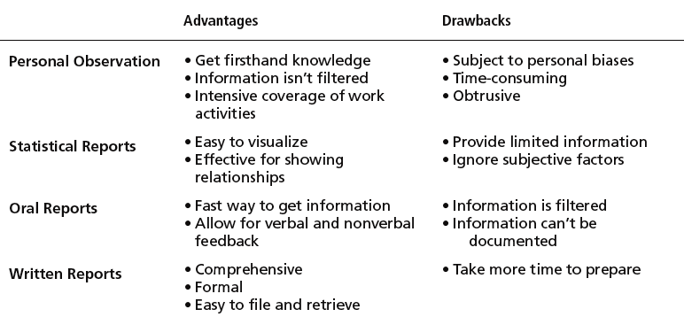

**Types of Control**

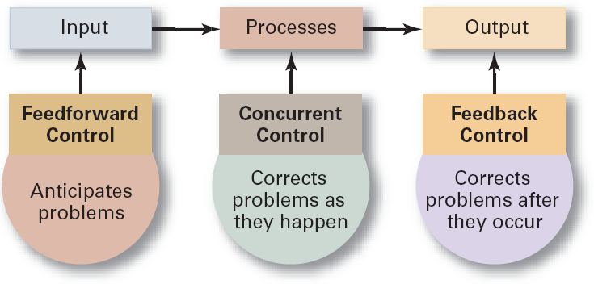

* **Feedforward Control**
  + A control that prevents anticipated problems *before* actual occurrences of the problem.
    - Building in quality through design.
    - Requiring suppliers conform to ISO 9002.
* **Concurrent Control**
  + A control that takes place while the monitored activity is in progress.
    - Direct supervision: management by walking around.
* **Feedback Control**
  + A control that takes place after an activity is done.
    - Corrective action is after-the-fact, when the problem has already occurred.